**EXPERIMENT-2: Title: DIVIDE AND CONQUER-I**

1. Implement Binary search and linear search and determine the time required to search an element. Repeat the experiment for different values of n, the number of elements in the list to be searched and plot a graph of the time taken versus n.

**Linear Search:**

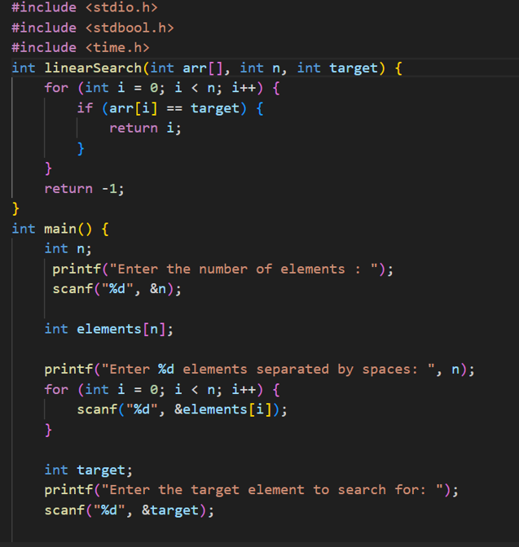

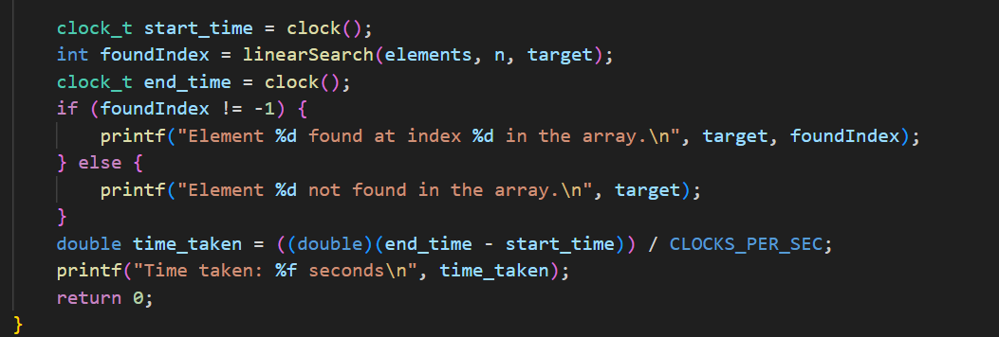

**Output:**

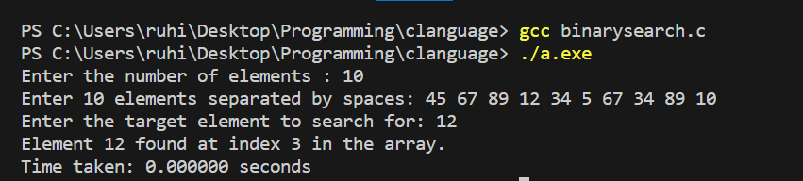

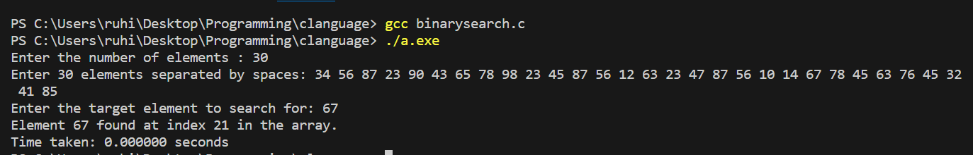

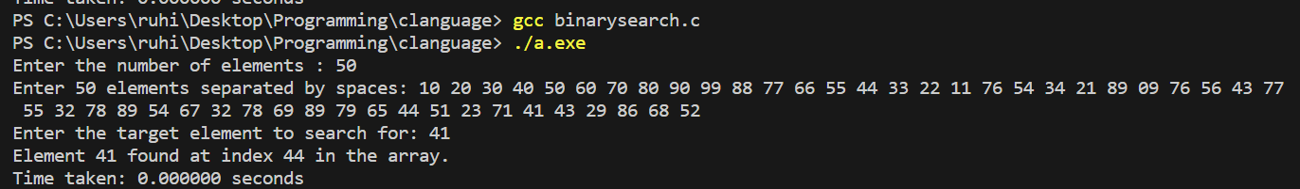

**Graph:**

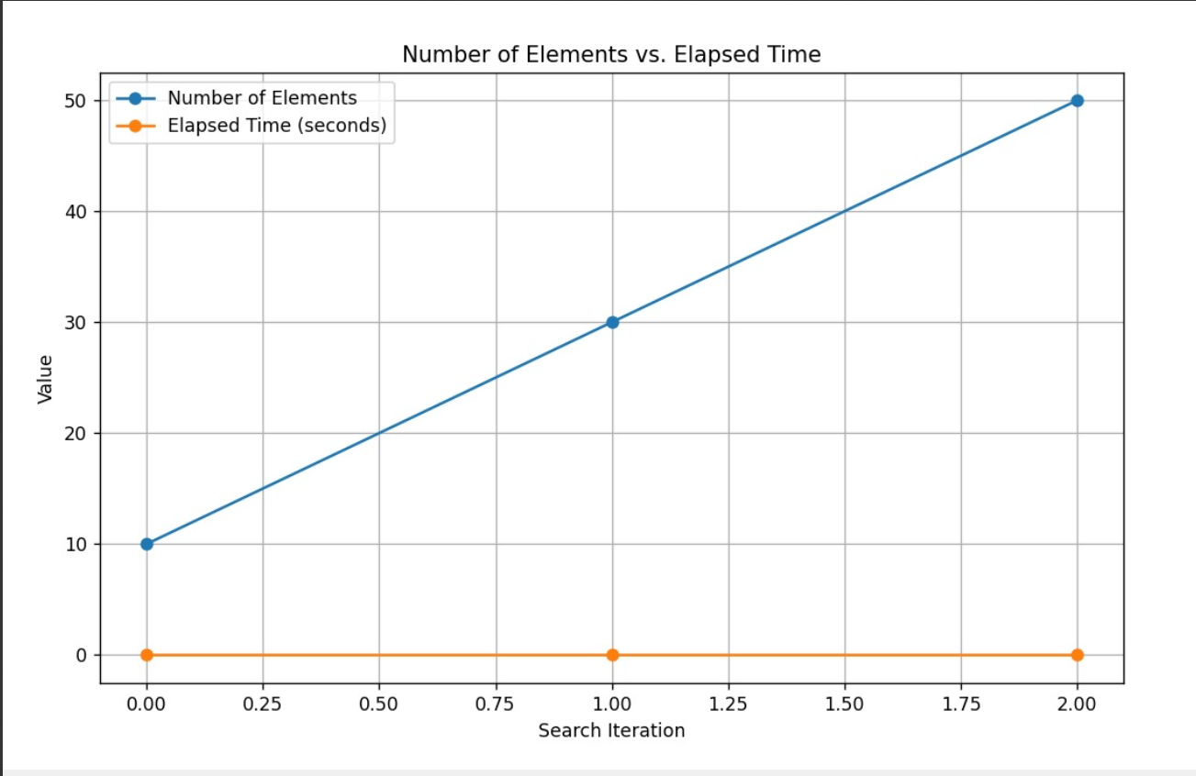

**Binary Search:**

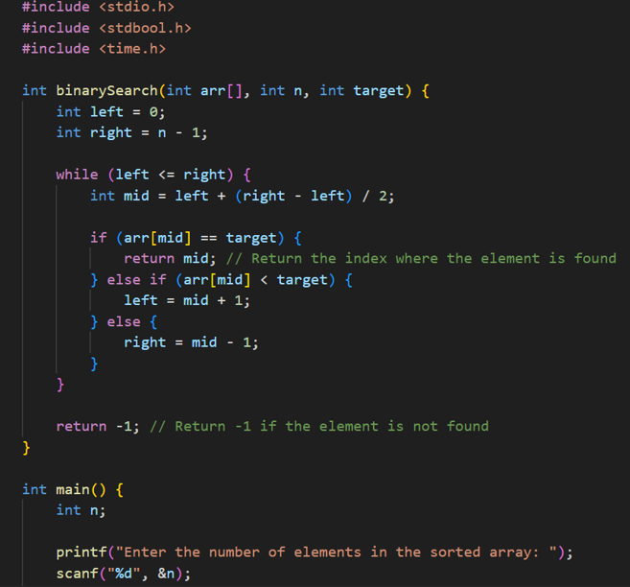

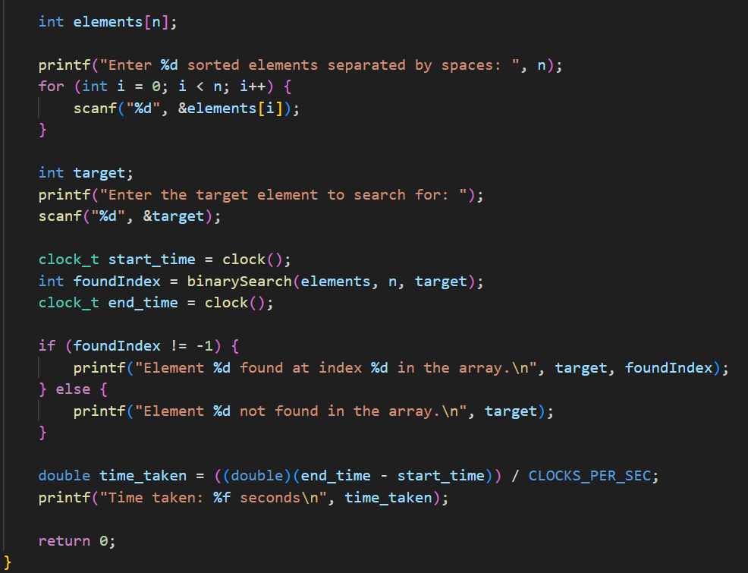

**Output:**

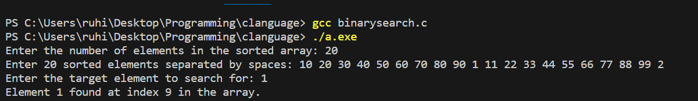

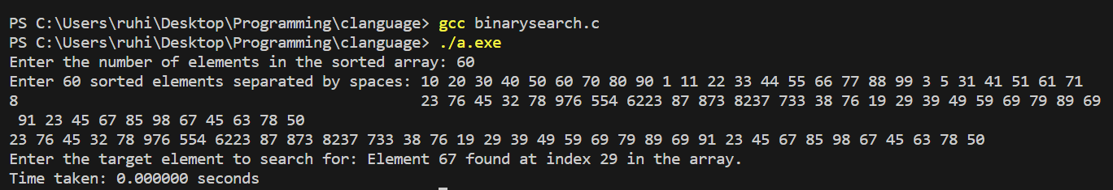

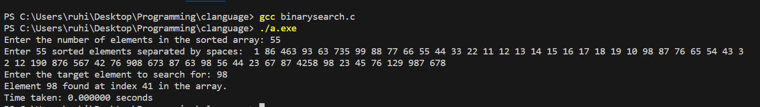

**Graph:**

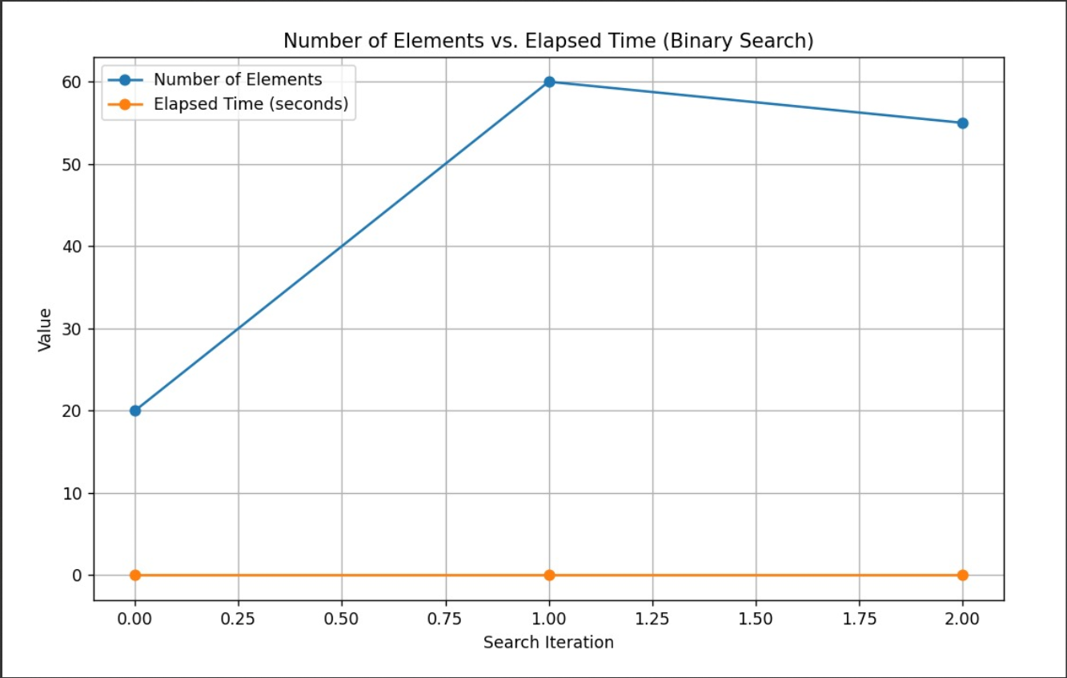

1. Search elements using the Binary search method and determine the time required to search the element. Repeat the experiment for different values of n, to search for the element in the list and plot a graph of the time taken versus n.

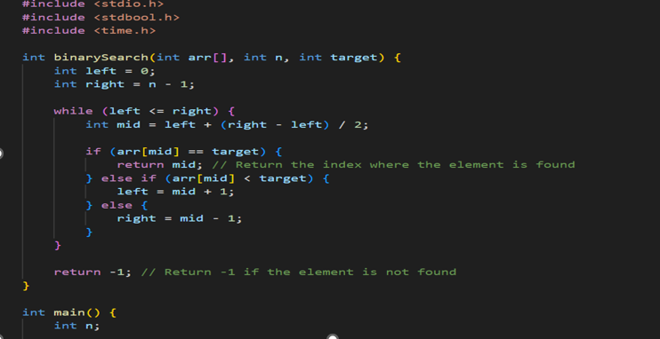

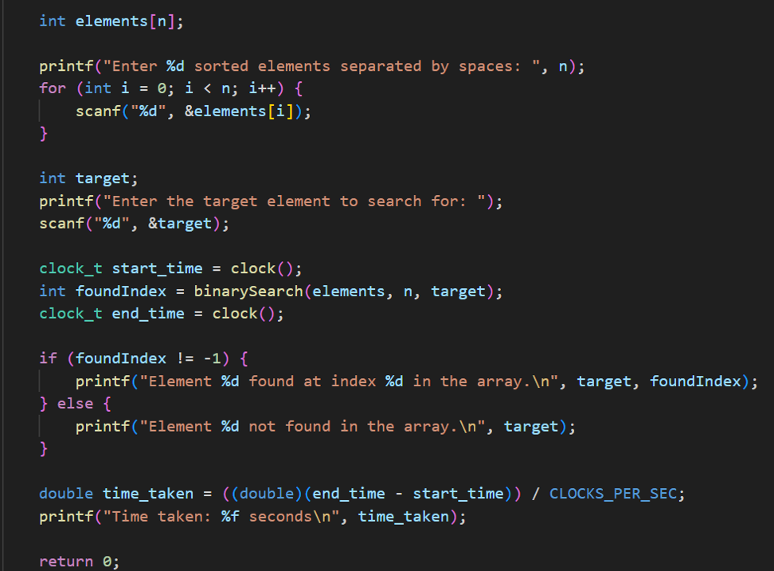

**Output:**

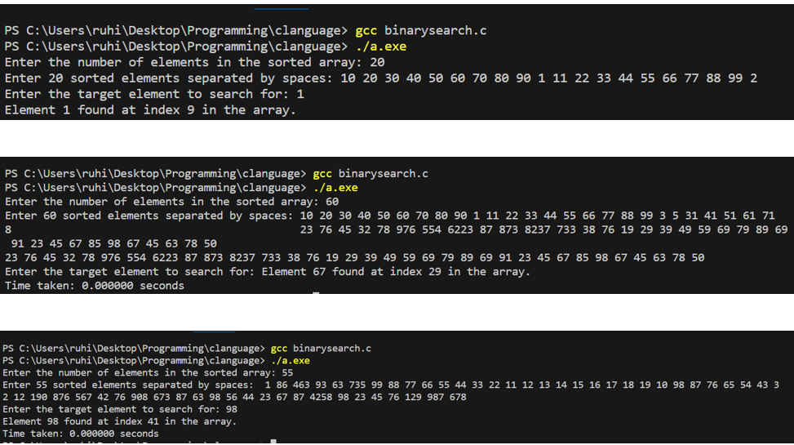

**Graph:**

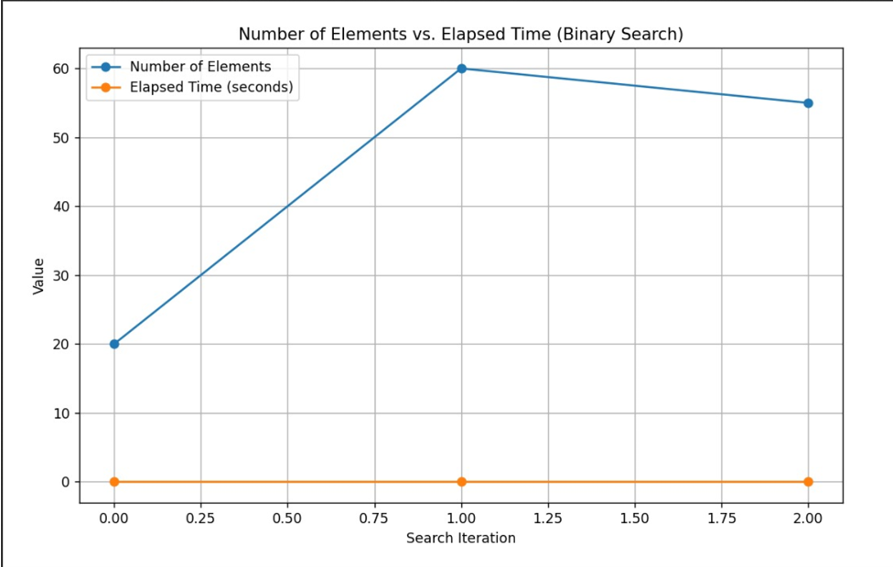

3.Sort a given set of elements using the Merge Sort algorithm to sort a given set of elements and determine the time required to sort the elements. Repeat the experiment for different values of n, the number of elements in the list to be sorted and plot a graph of the time taken versus n. The elements can be read from a file or can be generated using the random number generator.

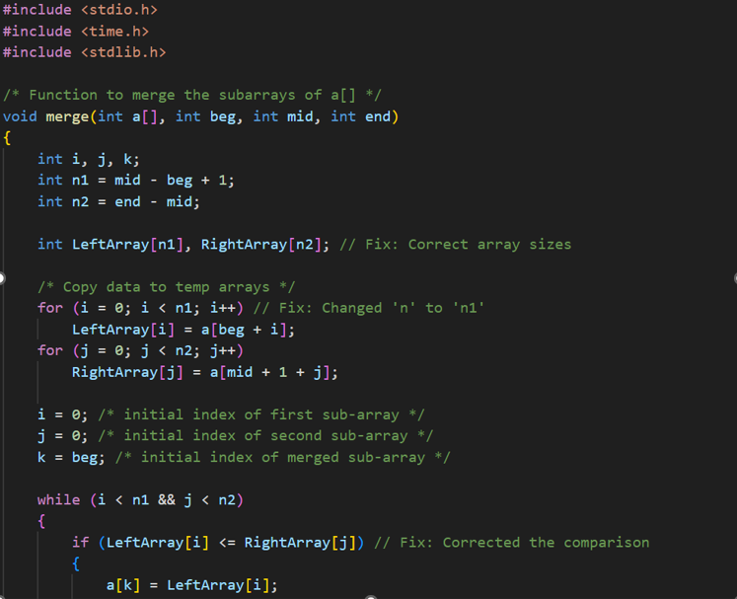

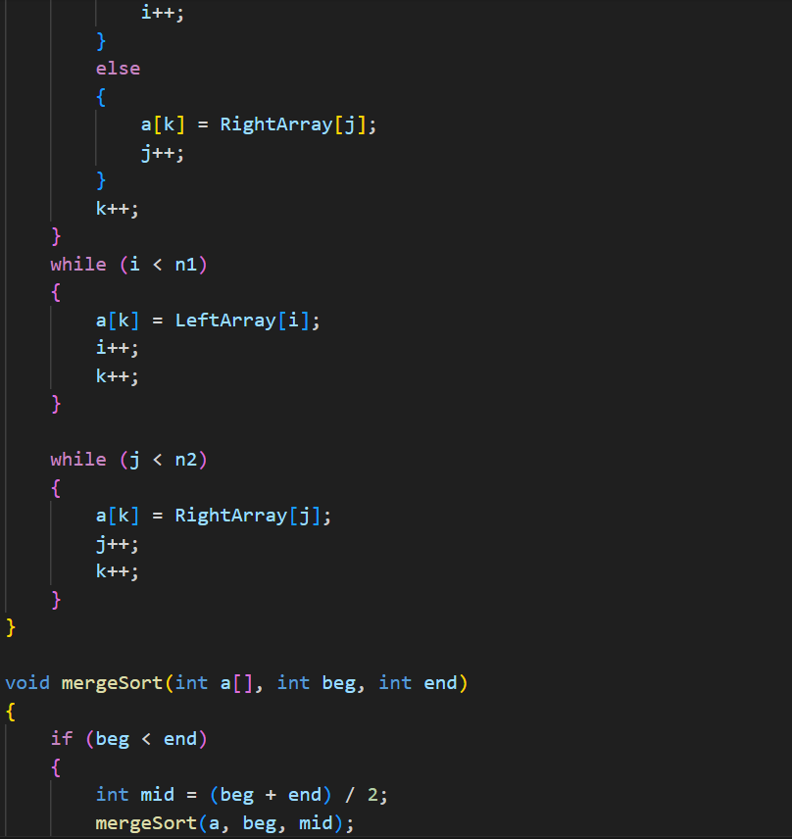

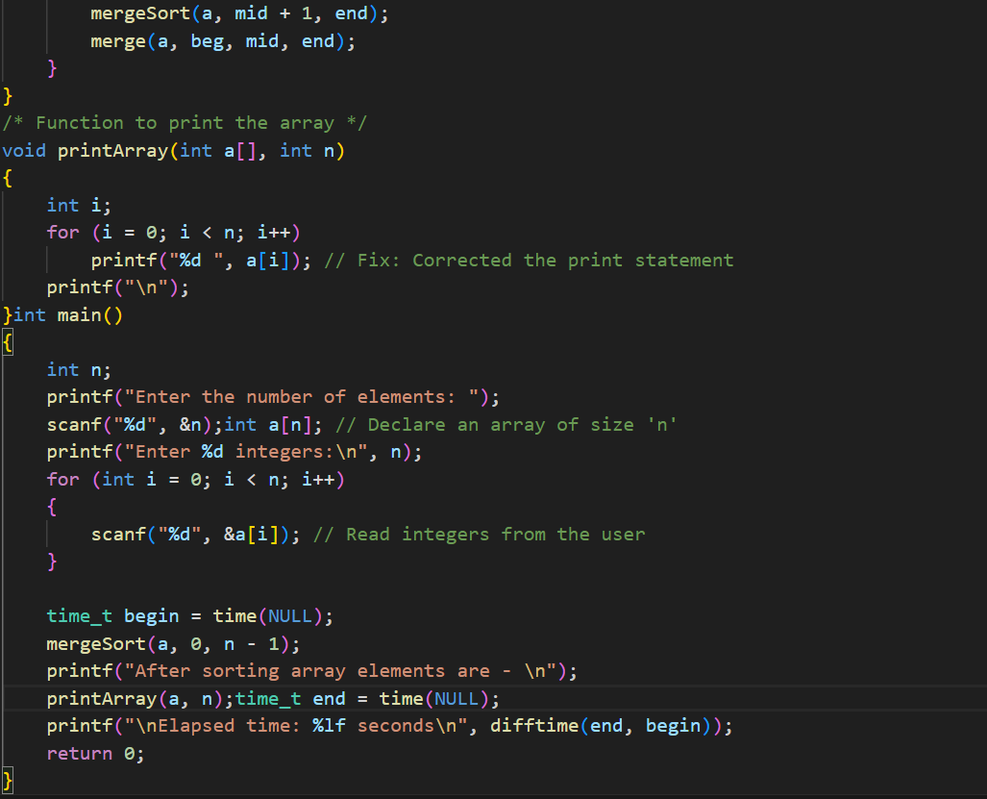

**Output:**

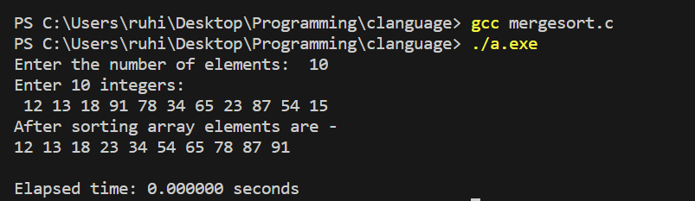

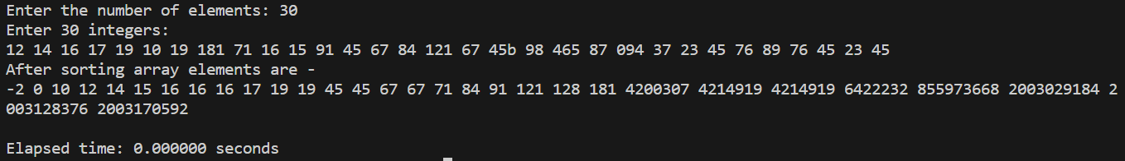

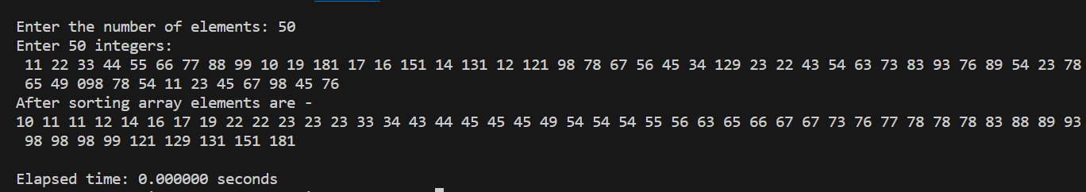

**Graph:**

